**Restarting the Workflow**

Go to Monitor Approvals Page:

Navigation: Main Menu > Enterprise Components > Approvals > Approvals > Monitor Approvals

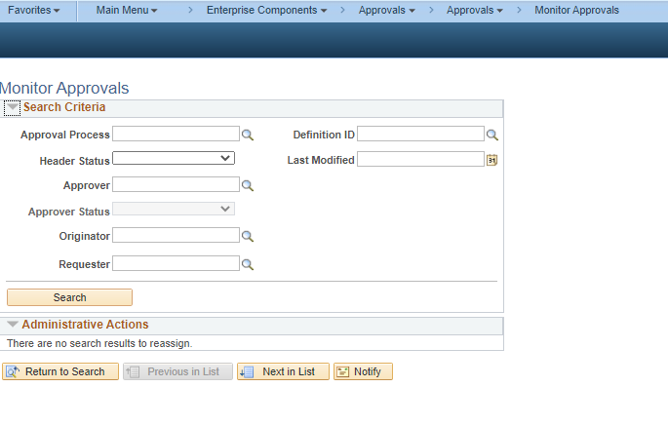

Provide the necessary inputs and click on search

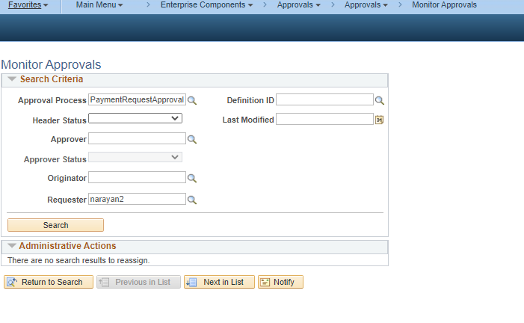

Enter the inputs and Click on Filter

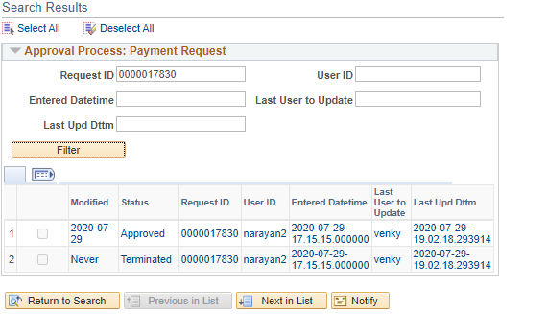

Click on the Results to open the Transaction,

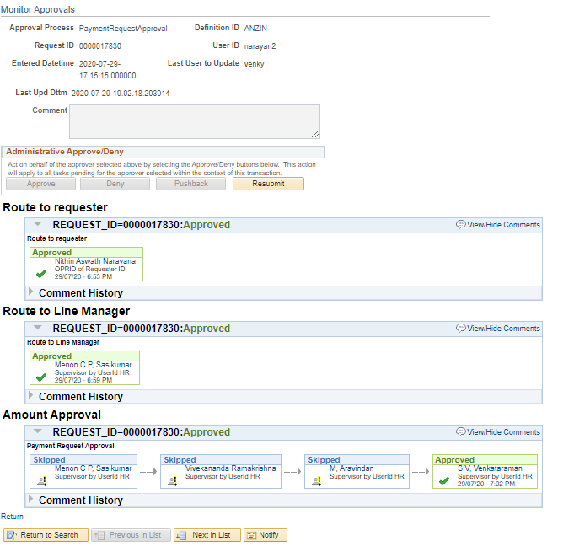

If the Transaction is Approved Click on Resubmit, Else Click on Restart

